**Lesson06 Explore Docker Container in Azure App Service**

**Notes: -**

**1-in Azure Portal > Web App**

**(we check azure subscription and resource group)**

**(we select docker container with select O.S and select app service)**

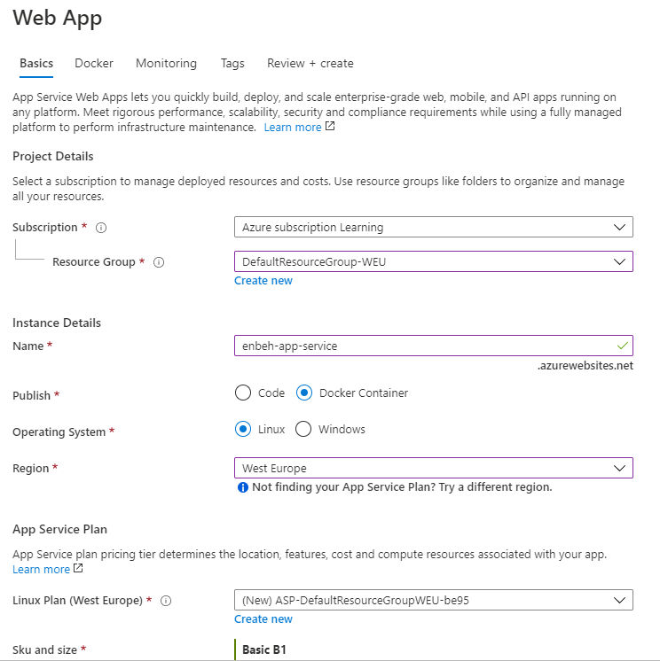

**2-we have the azure container registry and the custom docker image**

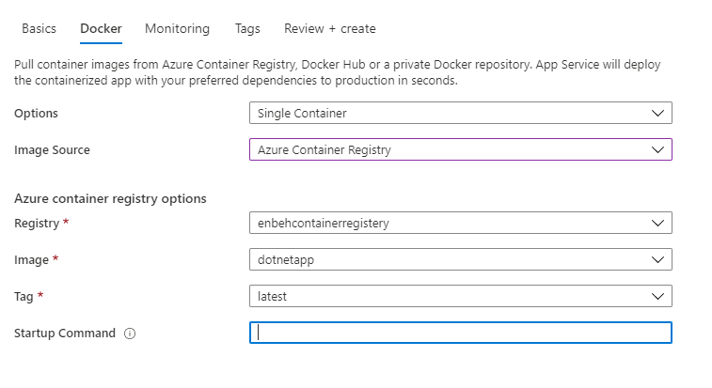

**3-we see it will create 2 resource azure service plan + app service**

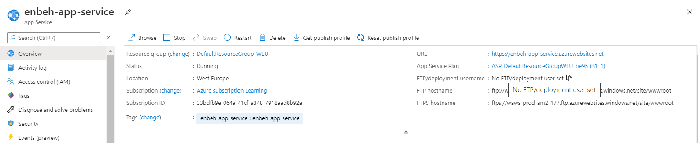

**Copy and paste URL and the custom docker image will be applied**